Taking Your Visuals to the Next Levelby Tiffany Davis
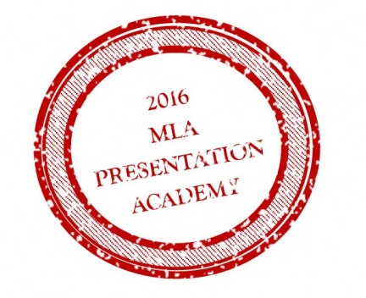

PowerPoint:
Your Powerpoint is to help and assist you presentation not heart it or do all the work for you.
You want the audience to pay attention to you and all about you powerpoint. They came to hear you present, not to read your presentation

How to do that: Keep it simple: less is more
Don’t use busy or distracting backgrounds
Keep the same color scheme
Don’t use multiple fonts
Don’t write paragraphs
One idea per slide
If you have to use bullet points keep it to no more the 6-7
Keep transitions and noise to a minimum
One image per side
If you can make the point in a graphic way do so
Maintain a cohesive train of thought and message flow
Don’t use unnecessary text animations or sound effects
Don’t use generic clipart

Prezi: https://prezi.com
Tips for when you are using Prezi:
Don’t have too many turns
Don’t have too many sides
Keep it simple

Design elements:

https://www.brainshark.com/ideas-blog/2012/March/best-powerpoint-fonts-for-killer-presentations

http://presentationsoft.about.com/od/powerpointtipsandfaqs/tp/080119powerpoint_font_tips.htm

http://www.thinkoutsidetheslide.com/choosing-colors-for-your-presentation-slides/

https://blog.slideshare.net/2014/03/17/how-to-use-colors-in-presentations

https://visage.co/11-design-tips-beautiful-presentations/

Posters:

Posters are the complete opposite of PowerPoint because you want your poster to do all the work; you are there just to expand more on it. We have all seen posters that are too much, and we just walk on by.

How to do that: Keep it simple: less is more

Don’t use busy or distracting backgrounds
Keep the same color scheme
Don’t use multiple fonts
Make sure your ideas follow the way people read
Only use graphs and images if they support the thought
Make sure you know your audience
Make sure you know the size your poster should be

Using PowerPoint to design a poster:

Templates of Academic poster sessions
http://www.posterpresentations.com/qtutorials/research-poster-template-quick-tutorials.html

http://library.nymc.edu/access/create_PPposter.cfm

Tips on scaling your poster
http://www.makesigns.com/tutorials/poster-sizing.aspx
Tips:
http://undergraduateresearch.as.ua.edu/presenting-your-work/making-posters/

Other Software:

Canva.com https://www.canva.com/create/posters/
Pros: Free limited options
Pre made layouts
Interface not to hard to navigate
Con’s: Must sign up for 30 day free trial if you want to resize

Fotojet https://www.fotojet.com/features/poster/
Format and interface similar to Canva.com

Other fun things:

Infographics:

Tips on How to make infographics with PowerPoint
http://offers.hubspot.com/how-to-create-infographics-in-powerpoint?_ga=1.229385372.1205634346.1469502893

Infogr
Example:
https://infogr.am/mla_annual_report_2015
Downside: you have to upgrade to be able to print out.

Piktochart
https://piktochart.com

https://piktochart.com/blog/layout-cheat-sheet-making-the-best-out-of-visual-arrangement/

Powtoon:
Short animated videos
Example:
https://www.powtoon.com/online-presentation/bx6IiDWDlH8/?mode=movie#/

