IFLA WLIC 2016 Congress
Resources for Poster 125

Reconnecting Persons with Dementia to their Libraries:
Using Library Materials to Improve the Quality of Life for People
Living with Alzheimer’s and Other Dementias

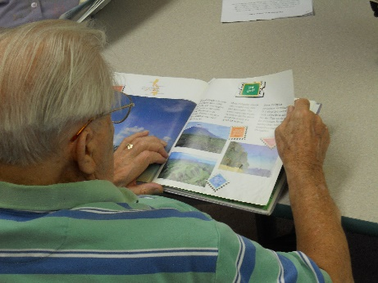

Case Studies

- Tales and Travel, Gail Borden Public Library Elgin, IL
  - http://talesandtravelmemories.com/about/
  - National Library of Medicine, Greater Midwest Region – 2015-2016 Target Project Award – Tales & Travel: Developing Community Partnerships to Expand Library Services. https://nnlm.gov/gmr/funding/funding-recipients/tpa
- ElderPlus Reading Program, Johns Hopkins Bayview Medical Center, Baltimore, MD
- Stories for Life, Springfield-Green County Library, Springfield, MO

  - http://thelibrary.org/seniors
- Library Memory Project, Bridges Library System, Waukesha, WI
  - www.librarymemoryproject.org
- Memory Care and Technology Program, Worthington Libraries, Worthington, OH
  - http://www.ala.org/pla/onlinelearning/webinars/ondemand/memory

Alzheimer’s & Related Dementias Interest Group (IGARD)

- an interest group of the American Library Association’s (ALA) Association of Specialized and Cooperative Library Agencies (ASCLA) Division - http://www.ala.org/ascla/interestgroups/igard
- National Survey of Current Practices - http://www.ala.org/ascla/sites/ala.org.ascla/files/content/asclaourassoc/asclainterest/LibraryServicestoPersonswithDementia.xlsx
(over)
Articles and Online Resources

- Benigas, J. E., & Bourgeois, M. S. (2012). Evaluating oral reading and reading comprehension in patients with dementia: A comparison of generic and personally relevant stimuli. Non-pharmacological Therapies in Dementia, 2(1), 41-54.
- Billington, J., Carroll, J., Davis, P., Healey, C., Kinderman, P. A Literature-Based Intervention for Older People Living with Dementia. University of Liverpool, Centre for Research into Reading, Information and Linguistic Systems. 2012. http://www.thereader.org.uk/media/56538/a_literature_based_intervention_for_older_people_living_with_dementia.pdf
- Dankowski, Terra. “Stimulating Minds: Libraries develop programs to serve patrons with Alzheimer’s Disease and other forms of dementia.” American Libraries, January/February, 2015, p. 54-57. http://americanlibrariesmagazine.org/2015/02/09/stimulating-minds/
- Freudenheim, Milt. “Many Alzheimer’s Patients Find Comfort in Books”. NYTimes.com. April 22, 2010. http://newoldage.blogs.nytimes.com/2010/04/22/many-alzheimers-patients-find-comfort-in-books/?_php=true&_type=blogs&_r=0
- Mortensen, Helle Arendup and Nielsen, Gyda Skat. Guidelines for Library Services to Persons with Dementia. International Federation of Library Associations and Institutions. 2007. http://www.ifla.org/files/assets/hq/publications/professional-report/104.pdf
- “Older People and Dementia.” The Reader Organization. 2013. http://www.thereader.org.uk/what-we-do-and-why/older-people-dementia.aspx
- Riedner, Mary Beth. (2015) Librarians’ Role as Part of the Care Team for Alzheimer’s Patients. Journal of Consumer Health on the Internet. 19(2): 143-47.
- Scott, Paula Spencer. Libraries Offer Alzheimer’s Activities for Senior Living: A “Novel” Idea Sweeping Memory Care Across the Nation. https://www.caring.com/resource_type_stories/libraries-alzheimers-activities-senior-living
Related Organizations
- Alzheimer’s Association (US) - http://www.alz.org/
- Alzheimer’s Disease International - https://www.alz.co.uk/
- Dementia Friendly America - http://www.dfamerica.org/

For questions/comments/additional information contact:
Mary Beth Riedner – Chair, IGARD
mbried@comcast.net

